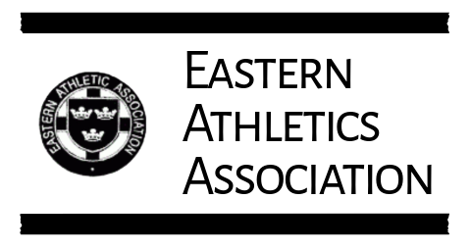
Privacy & Photography Policy

Photography & Use of Images
Eastern Athletic Association (EAA) may capture and use photographs and video footage taken at our events, competitions, and activities to promote athletics within the Eastern region. This may include use on our website, social media channels, event programmes, and other official communications.
We take care to ensure images are used respectfully and appropriately, and that no personal information is included unless necessary and agreed.
Opt-Out Option
If you do not wish to appear in any photographs or video content used by EAA, you may opt out at any time. To do so, please contact us at info@easternaa.com with the subject line Photography Opt-Out.
When opting out, please include:
- Your full name
- Club (if applicable)
- The events you attend regularly
- Any specific concerns we should be aware of
We will make every reasonable effort to avoid capturing or using images of individuals who have opted out. However, please note that at large public events it may not always be possible to guarantee complete exclusion from wide-angle or crowd shots.
Photography of Children & Young People
For athletes under 18:
- Parents/guardians may opt out on their behalf using the same process.
- We will not publish identifying information (e.g., full names) alongside images of minors unless explicit consent has been provided.
- We follow UK Athletics safeguarding guidance regarding the use of images of young people.
Third-Party Photographers
Occasionally, accredited photographers may be present at events. They are required to follow EAA’s safeguarding and privacy standards. If you have opted out, we will notify official photographers where possible.

